PROFILE
 | BALAKRISHNA PANICKER.M.G  Pisharam House,Temple Road North end  S.C.Road, Kadavanthra P.O  Kochi , Ernakulam District  Kerala, India – 682 020  Mob : 09745340055  E-mail : balakrishnanmg@gmail.com |  | 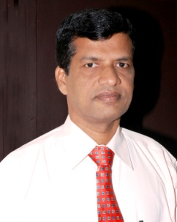
ACADEMIC PROFILE | M.B.A (1998)  L.L.B (1992)  M.Sc (1982)  Currently | Marketing Management, Bharatidasan University, Tamilnadu  Labour Laws, M.G.University, Kerala  Statistics, Cochin University, Kerala  doing Research in Management
CERTIFICATIONS | Mind power training from Lifeline,  Financial Advisor from AMFI and NISM- Currency Derivative.
JOB RESPONSIBILITIES  (20 yrs + Experience) | Chief Operating Officer, DSE Financial Services Ltd, New Delhi.  Vice President (Training), Muthoot Securites Ltd, Cochin, India.  Executive Director, Cochin Stock Exchange Ltd, Cochin, India.  Manager, Bancassurance, Principal Pnb Mutual Fund, Mumbai, India.  Business Development Manager, UAE Exchange & Finance Ltd, Cochin, India.  State Head- Kerala, UTI Securities Ltd, Mumbai, India.  Manager, Geojit Financial Services Ltd, Cochin, India.  SR. Finance Officer, Madras Fertilizers Ltd (Govt.of India P.S.U), Chennai, India.
TRAINING ATTENDED | Mind Power Mastery & Alpha Mind Power.  Change, Conflict &Team Management, Personality Development,  Goal setting, Social Media Marketing.  Market Research & Statistical Survey.  Capital Market, Mutual Funds & Commodity.  Software Packages Ms-office / DOS / FoxPro-2.5 /  Windows 95 / VB–6, ORACLE – 7/8.
TRAINING GIVEN | Mind Power, H.R.D & Management, Law.  Investment & Capital Market, Motivation related subjects
CURRENT INTERESTS | Research,Training and Development in areas of MIND POWER, H.R.D,  Leadership and Management, Law, Financial Intelligence,  Investment, Capital Market, Mutual Funds , Freelance Writing
NATIONALITY/ BORN | Indian / 10 May 1959

